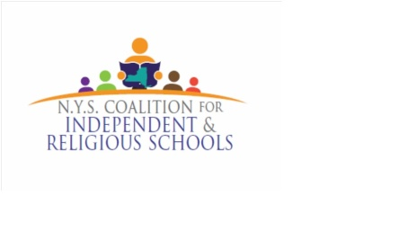
NYSCIRS Federal Funds Coordination
Intent to Participate
2021-2022

Principal/Administrator Name: ______________________________________________________________________
Title:_____________________________________________________________________________________________
School Name: _____________________________________________________________________________________
Address: __________________________________________________________________________________________
Phone Number: ___________________________ Email: _______________________________________________
Diocese/Affiliation: ________________________________________________________________________________

LEA/Public District Name:__________________________________________________________________________

LEA Address: _____________________________________________________________________________________

LEA Title Coordinator's Name: ______________________________________________________________________

LEA Title Coordinator Email Address: ________________________________________________________________

LEA Title Coordinator Phone Number: _______________________________________________________________

---------------------------------------------------------------------------------------------------------------------------------------------
Please attach a copy of the summary page of the Private School Participation Form OR please indicate your Title IIA allocation for 2021-2022 below.

$______________________________

Please attach a copy of the summary page of the Private School Participation Form OR please indicate your Title IV allocation for 2021-2022 below.

$______________________________
Please submit this form with supplemental information to: Federal Programs Coordinator - NYSCIRS - PO Box 4761, Halfmoon, NY 12065
or email nyscirs338@gmail.com

